**Assignment 6.1.3**

**Find out how many people has chosen airline mode of travel for the places LAS and LAX**

**Input Text Data:**

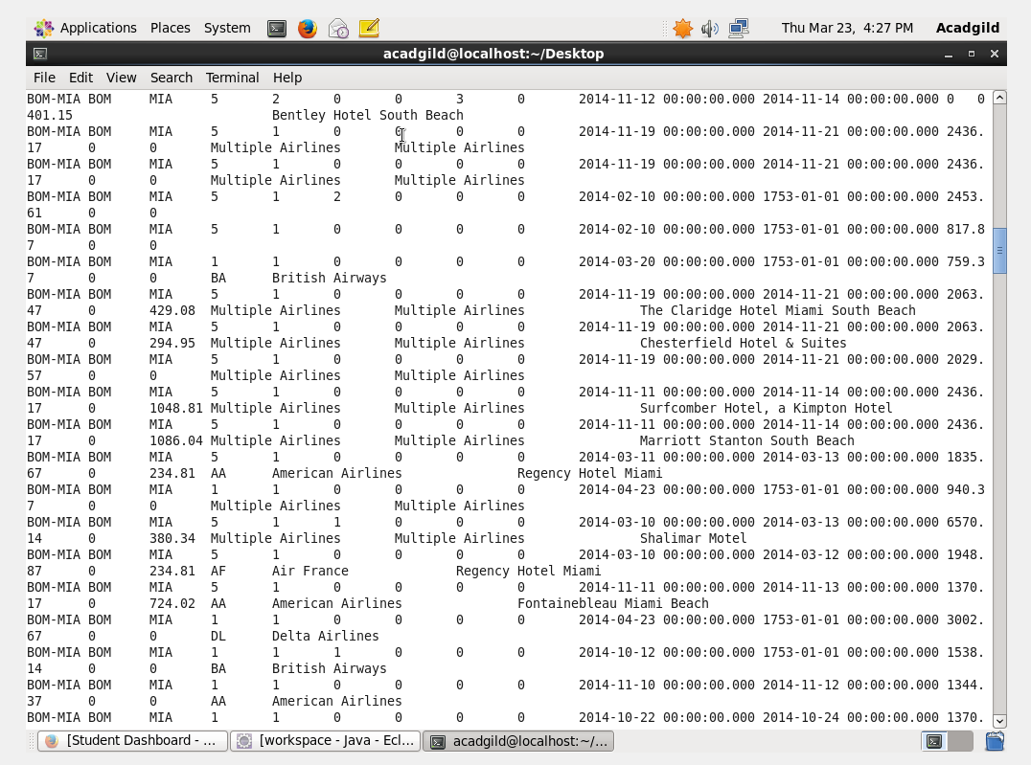

**Task Driver:**

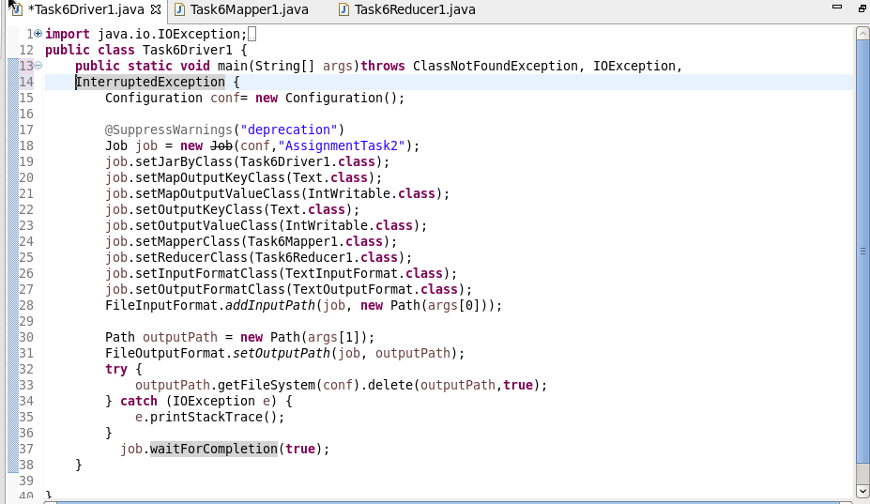

**Task Mapper:**

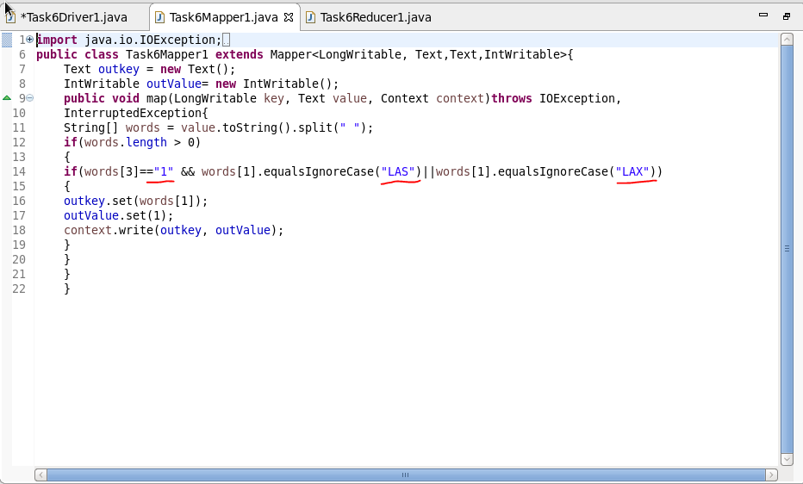

**Task Reducer:**

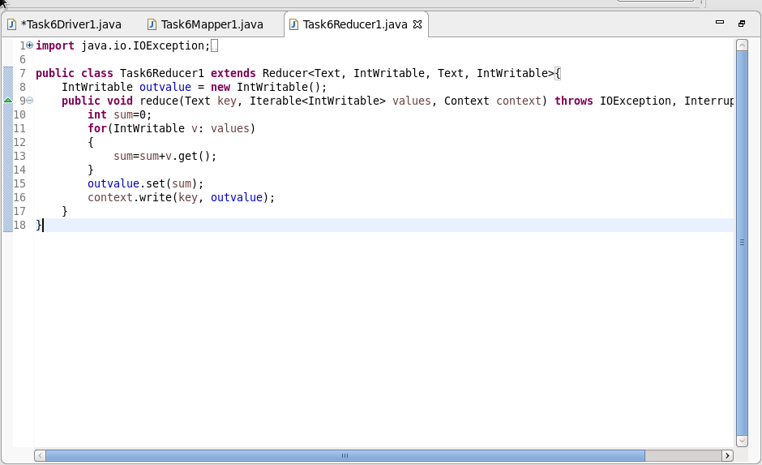

**Output:**

